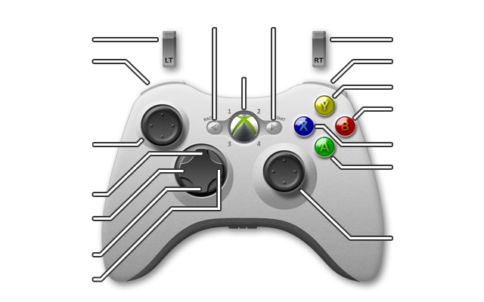
View Forward Left

STAR WARS: X-WING

ActionPad2 (hold) /
Decrease Throttle
ActionPad (hold) /
View Forward
View Forward Right
Hotkey/Directive
Toggle Shield Config.
Display
Map
Select Nearest Target
Joystick: Flight Control Click: Adjust Laser
Recharge Rate

Increase Throttle
Select Target / Roll (hold)
Fire Weapon
Joystick: Up
Left [View] Right
Rear
Click:
Adj. Shield Recharge Rate
Toggle CMD/Target Mode
Select Previous Target
Toggle Wing Position
Select Next Target

ActionPad (RT) | ActionPad2 (LT)

R2.Confirm | Cmd-”Rpt In”
Damage Report | Cmd-”Evasive Maneuvers”
Toggle Firing Config. | Cmd-”Engage”
Toggle Weapon Systems | Cmd-”Attack Target”
- | Menu Cursor Left
- | Menu Cursor Down
- | Mouse Cursor Right
- | Menu Cursor Up

Engage
Hyperdrive

Options
- | Cmd- ”Cover.Me”
Joystick: Full Throttle
Rear L [View] Rear R
Zero Throttle
Click:
Energy, Lasers→Shields
Click:
Energy, Shields→Lasers

